Name: - Aakash Singh
Email: - aakashsinghrajput8610@gmail.com
Website: -https://Microlink.co.in
Vulnerabilities: - Authentication Access Control.

1. Reconnaissance:
Subdomain enumeration was performed using tools such as subfinder and crt.sh.
The target webmail portal https://microlink.co.in was identified.
url:- https://webmail.logix.in

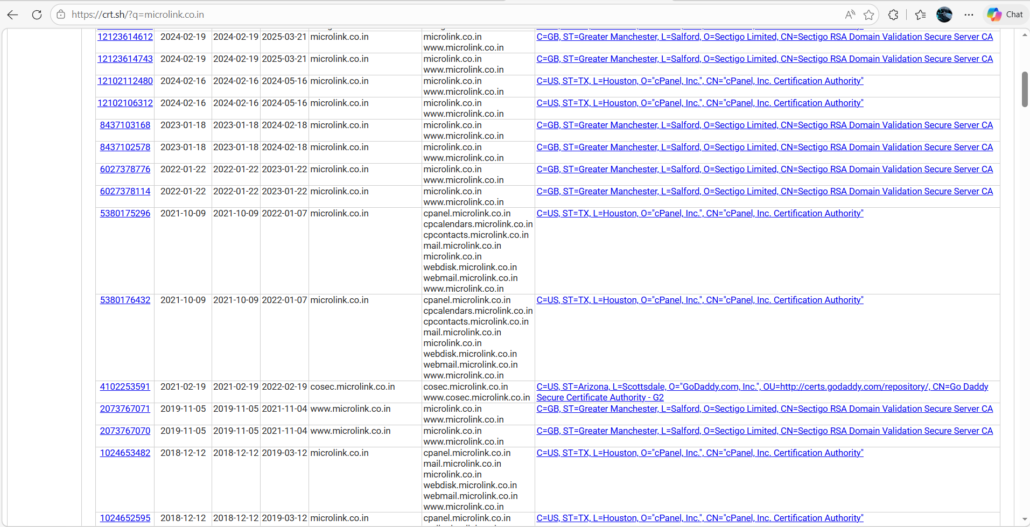

2. Accessing Login Portal:
The webmail login page was accessed successfully URL https://webmail.logix.in/ 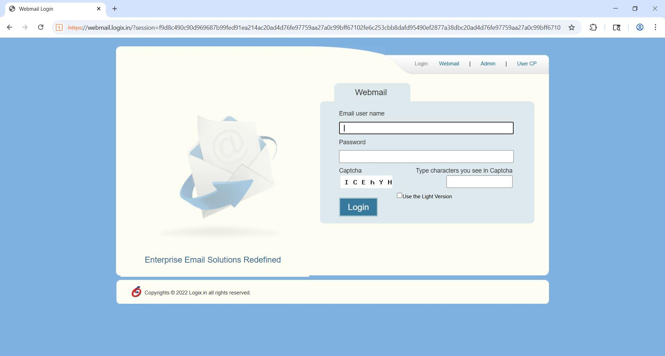

3. Password Pattern Analysis:
Using social engineering insights, common password patterns were identified.
Initial test password used: test2000.
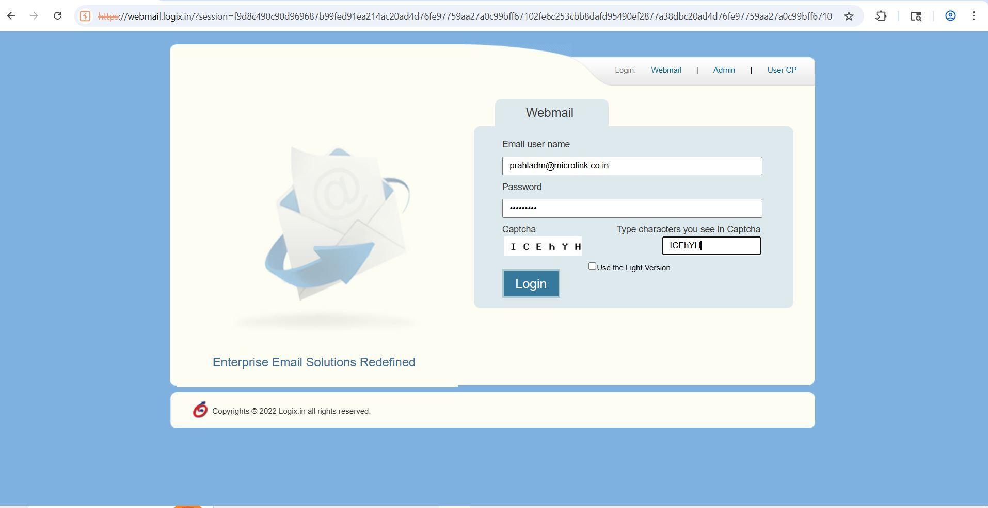
4. Request Capture:
Login request was captured using Burp Suite.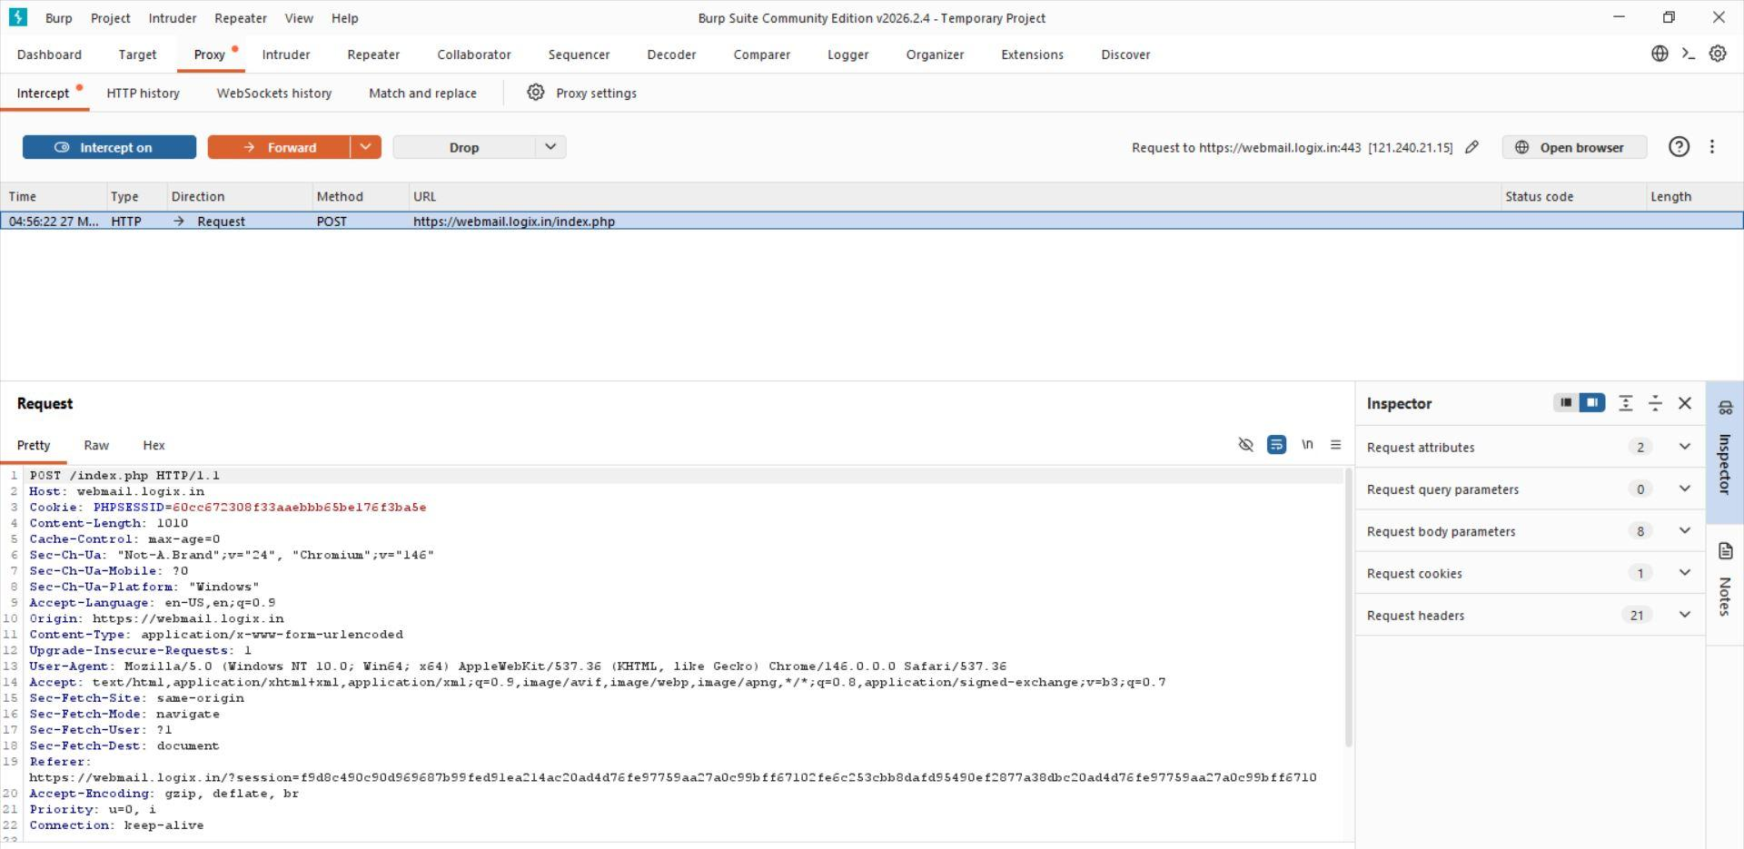

5. Repeater Testing:
The request was sent to Burp Repeater.
Server response: HTTP 200 OK but login failed (invalid credentials).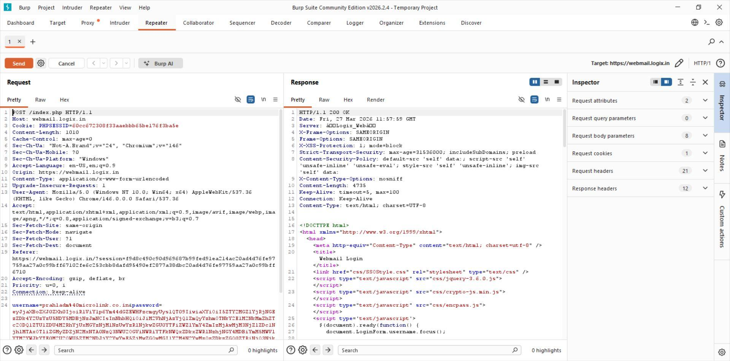

6. It showing incorrect password.
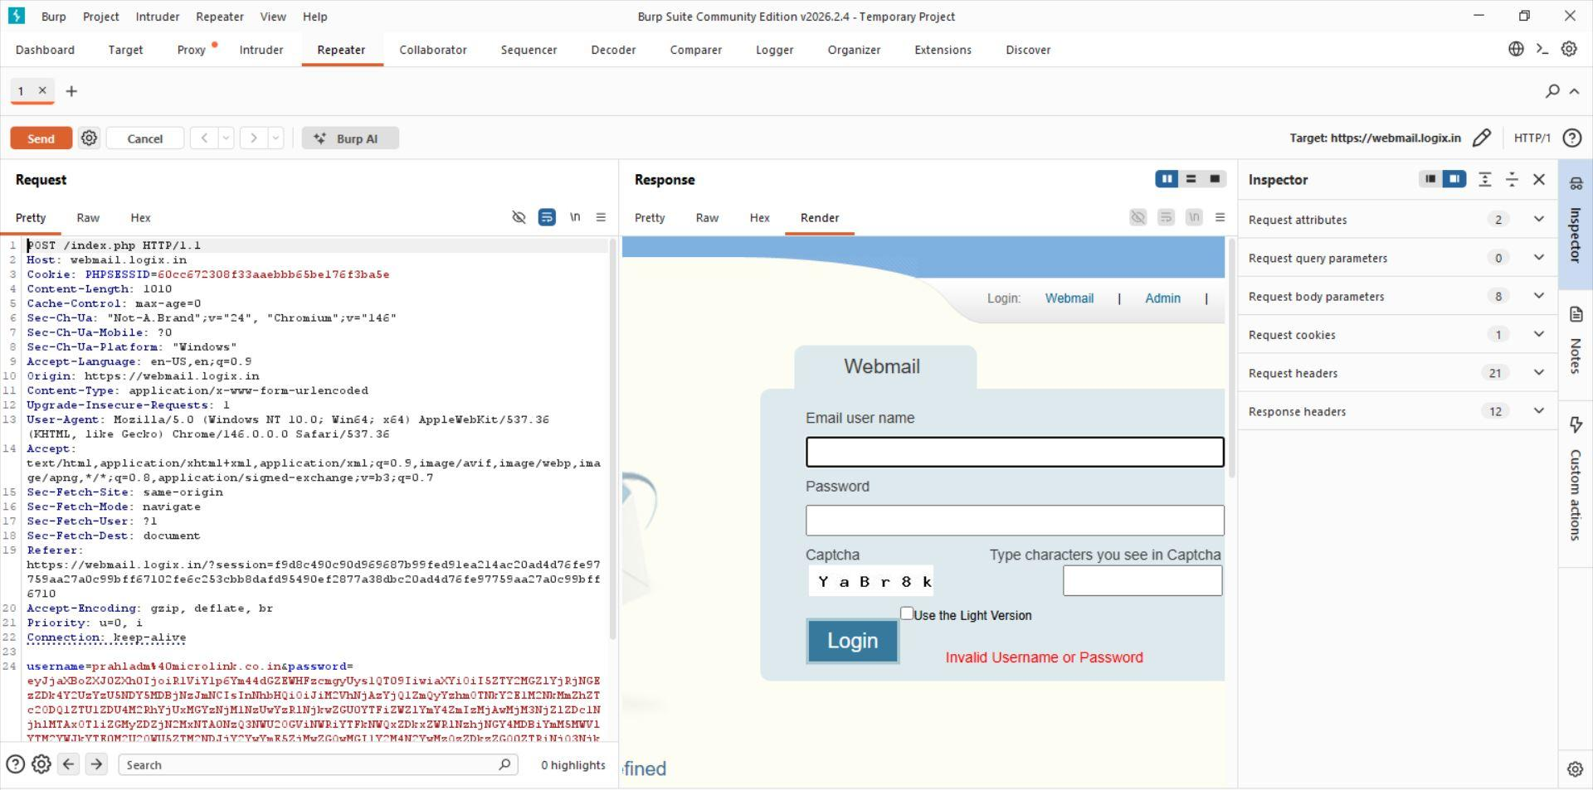

7. Brute Force Attempt:
The request was sent to Burp Intruder with a custom wordlist:
Pattern: Month Year (special character).
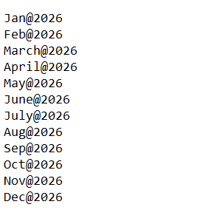

8. Response Analysis:
A deviation in response was observed:
- Incorrect passwords → HTTP 200
- Valid password → HTTP 302 Redirect
Image 1.
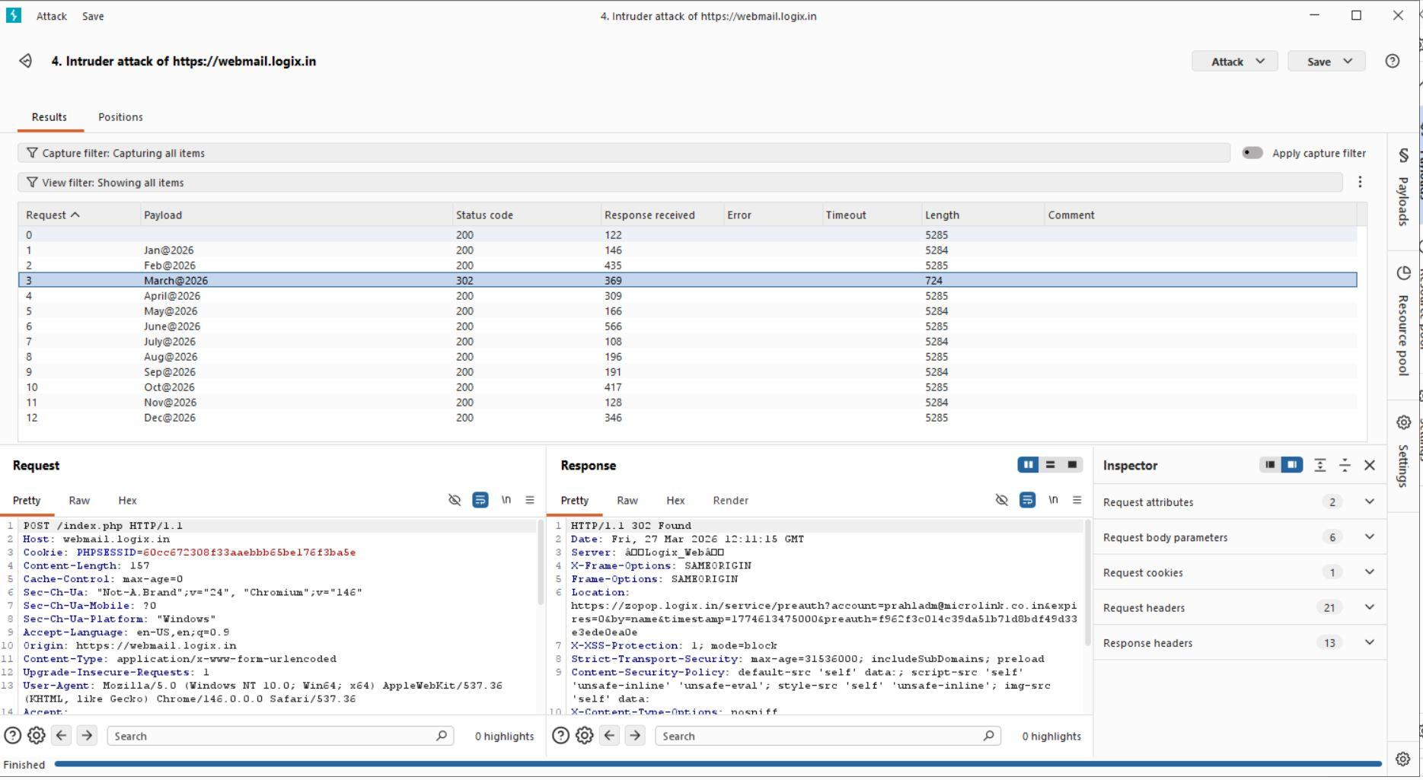
Image 2.
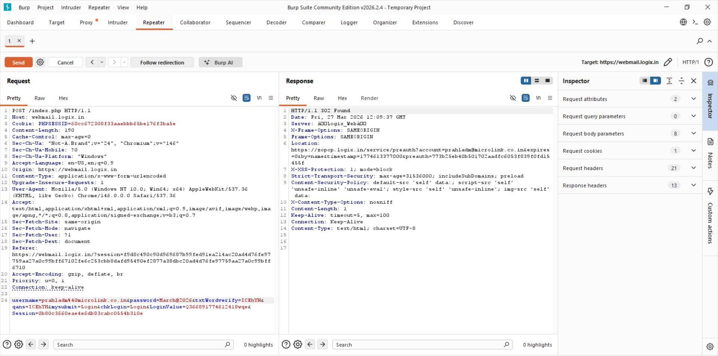
9. Credential Discovery:
Valid credentials identified:
Password: March@2026
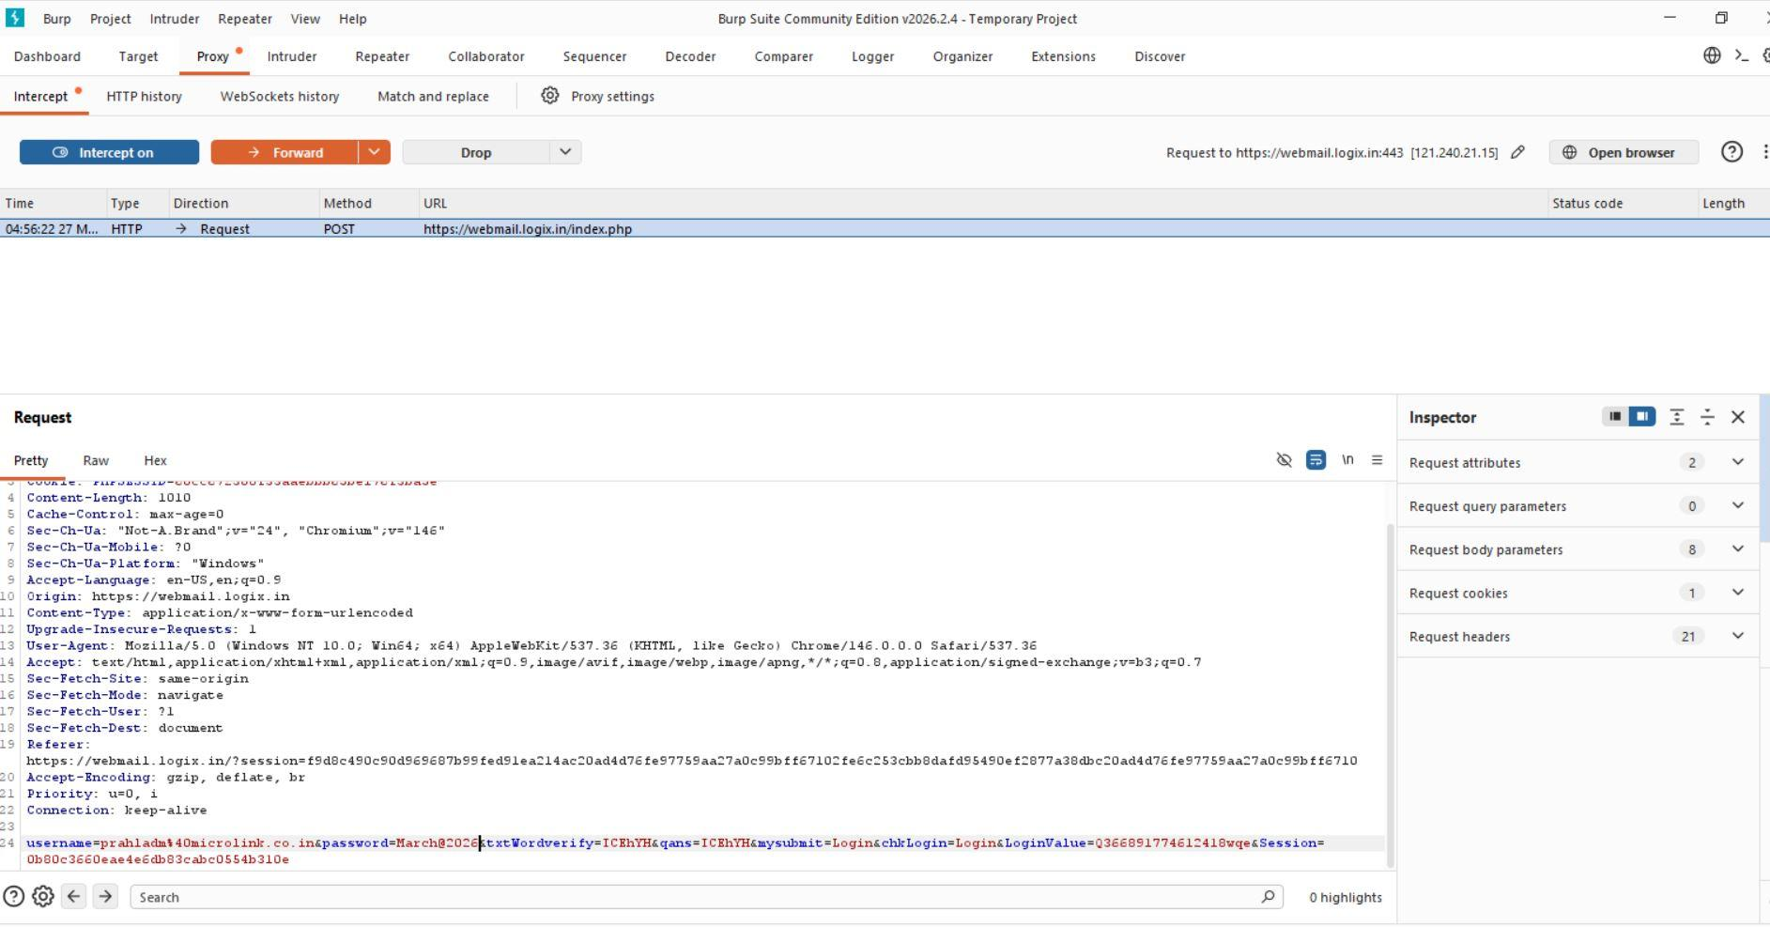

10. Account Access:
Successful login was achieved using the discovered credentials.
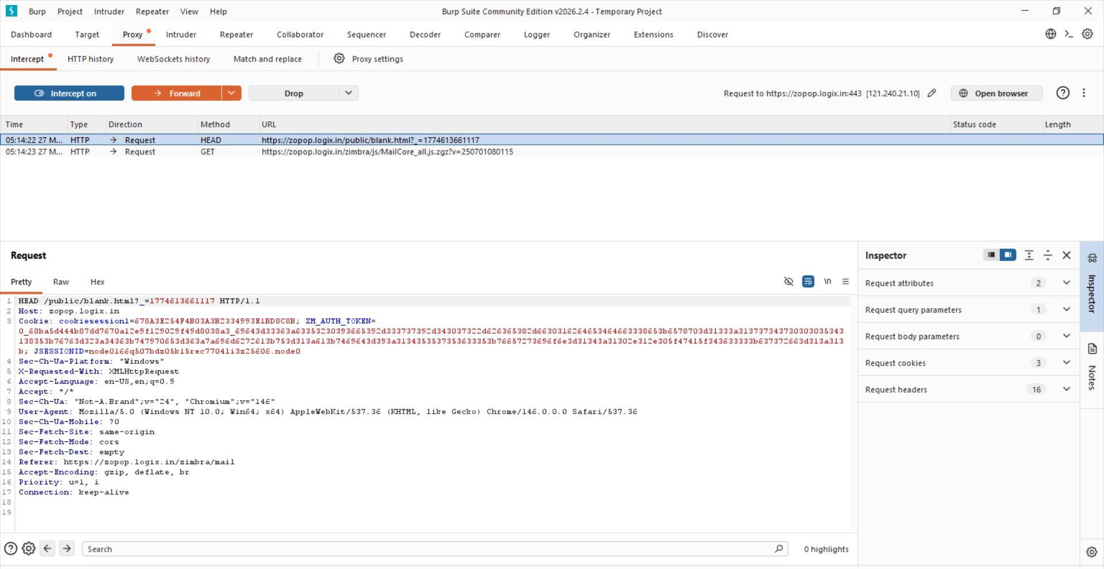

11. get the account successfully
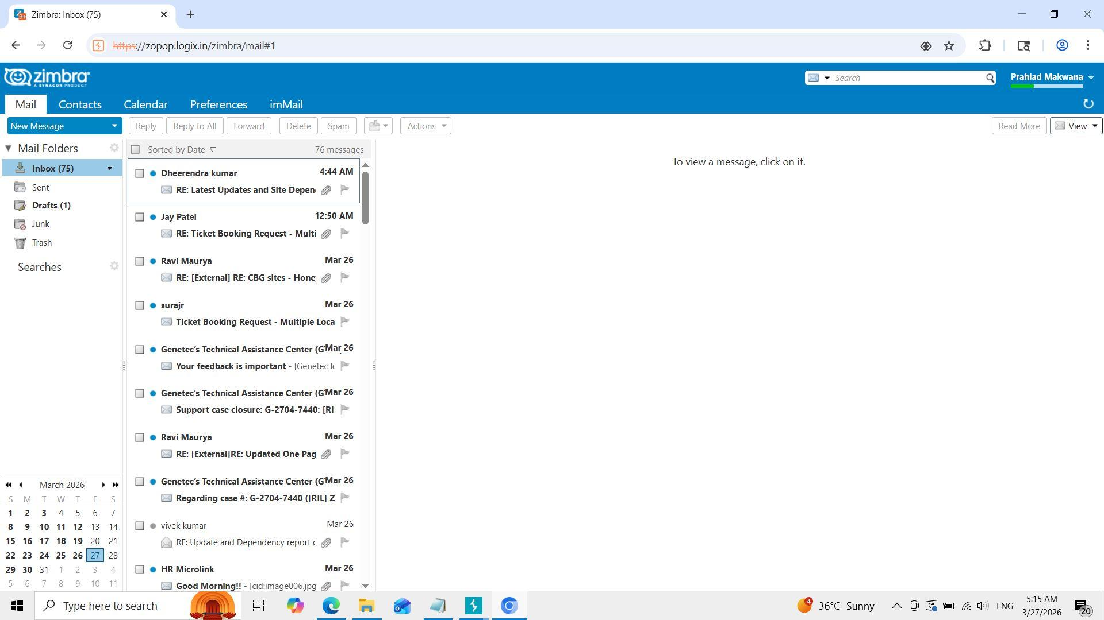

Impact:
- Unauthorized access to user account

